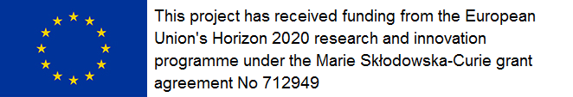

Periodic Report
Reference Period (from dd.mm.aaaa to dd.mm.aaaa)

Mobility Type:
Project number:
Project Title:
Fellow:

Scientific coordinator at host organisation

Organisation name:
Scientific coordinator:
Phone:
E-mail:

1 – Publishable summary
The content of this section may be used to advertise the project results in newsletters and/or websites. Please succinctly describe the objectives of the project and the expected results. You may use figures.

  - Project content and objectives

  - Expected results and impact

1.3 Contact and website

2 – Work progress and achievements during the period
2.1 Technical plan and corresponding achievements
This section must summarize the activities developed and progress towards the objectives and expected results described in your application for the whole period.
Outgoing mobility fellows shall indicate the centre they are working at for the period (Catalan host entity or host institution abroad).

2.2 Training activities
This section must summarize training activities carried out for the whole period and its impact for the project and the fellow.

2.3 Publications
This section must summarize papers, presentations and publications of any matter during this period.

3 – Transfer of knowledge objectives for the next period
3.1 Planned collaboration with other institutions: companies, research organisations, R&D projects involving companies, etc. Please indicate plans to pursue ongoing collaborations or establish new ones.

3.2 Planned technology transfer activities: patent applications or IP registration, license agreements, spin offs creation, etc. Please indicate plans to transfer the expected results of the project.

3.3 Other important information: guidelines standards, PhDs…. Please indicate any other expected results for the next period.

Date

Fellow signature

Scientific coordinator at host organization signature

