REPORT ON THE ACTIVITIES CARRIED OUT – YEAR 1
From starting date to ending date
Acronym of the project
ANNUAL REPORT FOR TECNIOSPRING INDUSTRY PROJECTS CALL 2019
generalitat de catalunya, acció
Project ID code starting with TECSPR19
Name of the Researcher

INSTRUCTIONS

Please, carefully read the following instructions before starting to fill in the form.

WHAT?
The first Annual Report, or “Report on the activities carried out” as it is called in the Regulatory Bases, is one of the documents to be provided for the Annual Reporting (see Tecniospring Industry Guide 2019 call – Monitoring & reporting). Its objective is to describe the project implementation to justify the declared costs. It recompiles the information of the semi-annual reports nº1 and nº2.
- Project's general implementation
- Justification of expenditures

WHEN?
It is submitted within 2 months of the end of the 1st year of implementation (M14), as an annex to be uploaded directly on the Canal Empresa or EACAT.

HOW?
We have tried to simplify it as much as possible: all the fields that must be filled in are in grey and you are provided with detailed explanations to help you understand what information is required each time.
Do not forget to fill in the information on the 1st page and to rename the document as follows:

TECSPR19-1-0000_ANNUAL_REPORT_1

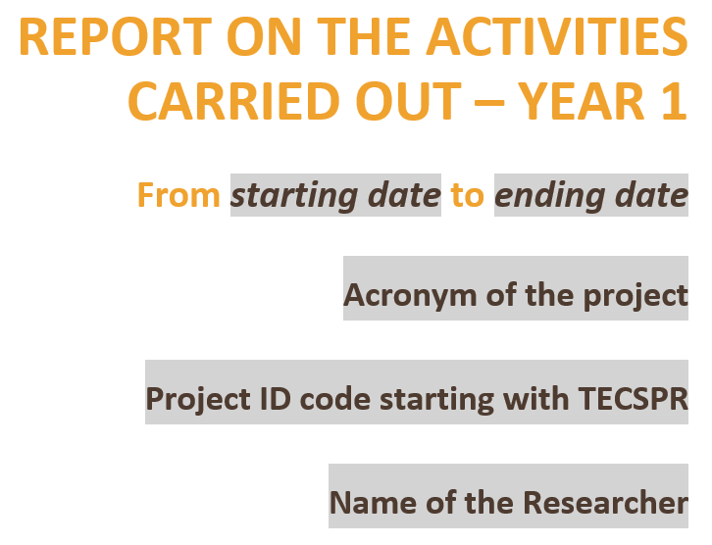
Project Tecniospring Identification Code

It is the code attributed to your project starting with TECSPR. You can find it on the Grant Agreement.
Starting date
1st day of the 1st month of the reporting period

Ending date
Last day of the last month of the reporting period

WHO?
The report must be jointly

WHO?
We remind you that the report must be written jointly by the Researcher and the Supervisor(s).

DO NOT FORGET TO SIGN THE REPORT!

TABLE OF CONTENTS
SECTION A: ADMINISTRATIVE INFORMATION 4
SECTION B: TECHNICAL REPORT 5
PART 1. PROJECT GENERAL IMPLEMENTATION 5
PART 2. JUSTIFICATION OF THE EXPENDITURES 5
SIGNATURES 6

SECTION A: ADMINISTRATIVE INFORMATION

BENEFICIARY (CATALAN HOST ORGANISATION)
Name of the organisation: | [Enter name]
Name of the supervisor: | [Enter name]
Position of the supervisor in the organisation: | [Enter position]

ABOUT THE PROJECT
Full title of project: | [Enter name]
Type of mobility: | Choose the modality

If you have selected Mobility A (outgoing and return), please also fill in the following table.

ABROAD HOST ORGANISATION (MOBILITY A)
Country: | [Enter name]
Name of the organisation: | [Enter name]
Name of the supervisor: | [Enter name]
Position of the supervisor in the organisation: | [Enter position]
Actual starting date of the stay abroad: | Click or tap to enter a date
Actual/foreseen ending date of the stay abroad: | Click or tap to enter a date

SECTION B: TECHNICAL REPORT

PART 1. PROJECT GENERAL IMPLEMENTATION
Give a clear and concise overview of the project's implementation and progress made during the first year. Do not forget to describe:
- the progress made to achieve the objectives (see Proposal submitted, part 3.1)
- the detailed implementation of each activity
- the results obtained.
3 000 characters maximum
Click to enter text

PART 2. JUSTIFICATION OF THE EXPENDITURES

In this part, you are asked to justify all the expenditures you declared according to their category (except for personnel expenses). Please, add as many rows as expenditure you have declared.

MOBILITY EXPENDITURES
The mobility category consists exclusively of the Researcher’s travel expenditures to join the host organisation (in Catalonia or abroad). All other travel expenditures belong to the research category.

Description of the cost/expenditure | Original amount (foreseen in the proposal budget) | Actual amount  (declared, spent or foreseen) | Deviation?  (tick if yes) | Amount of the deviation  (if applicable) | Justification  (include explanations about the deviation if applicable)
Describe the expenditure (number of items, type, etc.) | Click to enter number | Click to enter number | ☐ | Click to enter number | Justify the expenditure by explaining for which activity it was needed, what purpose it served, etc.
To add a row, click on the + symbol that appears at the bottom-right side of the table.

RESEARCH EXPENDITURES

Description of the cost/expenditure | Original amount (foreseen in the proposal budget) | Actual amount  (declared, spent or foreseen) | Deviation?  (tick if yes) | Amount of the deviation  (if applicable) | Justification  (include explanations about the deviation if applicable)
Describe the expenditure (number of items, type, etc.) | Click to enter number | Click to enter number | ☐ | Click to enter number | Justify the expenditure by explaining for which activity it was needed, what purpose it served, etc.
To add a row, click on the + symbol that appears at the bottom-right side of the table.

PUBLICATION EXPENDITURES

Description of the cost/expenditure | Original amount (foreseen in the proposal budget) | Actual amount  (declared, spent or foreseen) | Deviation?  (tick if yes) | Amount of the deviation  (if applicable) | Justification  (include explanations about the deviation if applicable)
Describe the expenditure (number of items, type, etc.) | Click to enter number | Click to enter number | ☐ | Click to enter number | Justify the expenditure by explaining for which activity it was needed, what purpose it served, etc.
To add a row, click on the + symbol that appears at the bottom-right side of the table.

SIGNATURES

THE RESEARCHER | THE SUPERVISOR - CATALAN HOST ORGANISATION
Name: [Enter name] | Name: [Enter name]
Date: Click or tap to enter a date | Date: Click or tap to enter a date
Signature: | Signature:

THE SUPERVISOR - ABROAD HOST ORGANISATION
(only mobility A)
Name: [Enter name]
Date: Click or tap to enter a date
Signature:

